2020 Hannah’s House ministries, inc.

Some 2020 Hannah’s House Program Participants and Workers
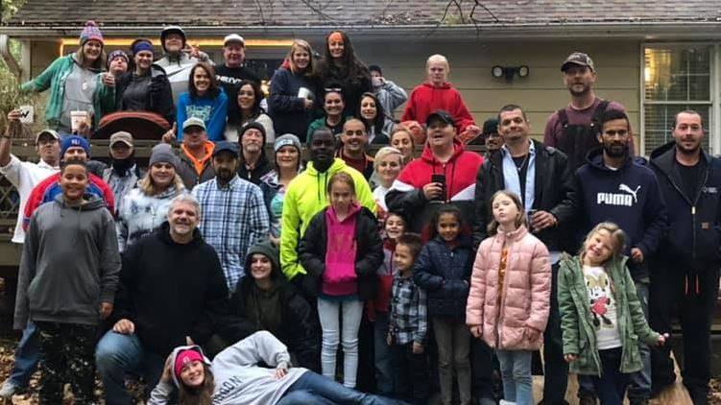
Your generosity has provided Housing and Utilities, Furniture, Food and Supplies, Life Empowerment, Discipleship training, Transportation and Staff for:
108 total residents in 2020
61 decisions for Christ and following the Lord in baptism
61 Men
37 Women
10 Children
Hannah’s House program asks for a 6-month commitment and are required to complete 6 contracts as participants to graduate. This training time transforms their life and gives them tools for success. Each contract they must complete summaries of required bible study, memorization of Bible verses, Character trait studies, and one book read with each contract along with a work zone chores and projects each day.
Here are some 2020 Average Monthly Expenses that your contribution provided:
Utilities: $3225.00 Food and Supplies: $580.00 Transportation, repairs and 2nd Van purchase: $1078.00 Benevolence: 150.00 Insurance, Payroll and other expenses: $4200.00 Maintenance on Homes: $1230.00 Training Materials: $125.00

Join us online Tuesday – Friday 9 am and 1 pm for chapel on Crystalbrook Church Facebook or see the Testimony Videos Online on the YouTube Crystalbrook Church Channel and go to the playlist. https://www.youtube.com/channel/UCkAQMTbS9h762ownPtMcjOQ/playlists
2020 Completed Building Projects:
Your generosity provided a completed security system at the men’s main house along with a new washer. Apartment Repairs for Re-Integration: Heat/Air unit and water heater replaced in one apartment and an air conditioning unit in a 3rd apartment. We were blessed by a wonderful couple who adopted one apartment, did renovation work, painting, hanging curtains, building a cabinet and completely furnished this space.
2021 Ministry Focus and Projects:
As we head into 2021 we are focusing on re-integration and the best way we can support our residents as they continue on the journey to their purposes God had planned from the beginning. The most successful graduates we have stayed connected for several years in the faith community which brings real friends who love them and bring the truth when needed. Projects: Continued the renovation work on a large donated home; Repair or Replace 2 roofs on Re-Integration Housing.

All monetary donations can be addressed to: Hannah’s House Ministries, Inc.
PO Box 176
Independence, KS 67301
Online Donations can be made at www.hannahshouseks.com or Text the number 73256 and then word Hannah

